**Name - Gaurang A Raorane Roll No - 49**

**Class - D15A Batch - C**

**EXPERIMENT NO - 4**

**Aim:-** Experiment to study advanced features supported by CSS3.

**Theory:-**

Basics of CSS3: CSS3, or Cascading Style Sheets 3, is the latest evolution of the CSS language used to style web documents. It introduces a wide range of new features and enhancements compared to its predecessor, CSS2. Here are some of the basics of CSS3:

* **Selectors:** CSS3 includes more advanced selectors, such as attribute selectors, pseudo-classes, and pseudo-elements, which allow for more precise targeting of HTML elements.
* **Box Model:** The box model in CSS3 has been improved to include properties like box-sizing, which allows you to control how an element's total width and height are calculated.
* **Colors and Backgrounds:** CSS3 introduces new color formats like RGBA (Red Green Blue Alpha) and HSLA (Hue Saturation Lightness Alpha) for specifying colors with transparency. It also offers more advanced background properties for gradient backgrounds and background images.
* **Borders and Border Images**: CSS3 provides enhanced border properties, including rounded corners (border-radius) and border images (border-image) for creating complex border styles.
* **Text Effects:** CSS3 offers features for styling text, such as text shadows (text-shadow), custom fonts using @font-face, and improved support for text wrapping and alignment.
* **Transitions and Animations:** CSS3 enables the creation of smooth transitions between property values using transition and allows for keyframe-based animations using @keyframes.
* **Transforms:** CSS3 includes 2D and 3D transformation properties (transform) for manipulating the position, rotation, and scaling of elements.
* **Flexbox Layout:** CSS3 introduces the flexible box layout model (flexbox), which simplifies the creation of complex layouts and alignment of elements within a container.
* **Grid Layout:** CSS3 Grid Layout (grid) provides a powerful system for designing two-dimensional layouts with rows and columns.
* **Media Queries:** CSS3 includes media queries for designing responsive layouts that adapt to different screen sizes and devices.
* **Multiple Columns:** The column-count and column-gap properties allow you to create multi-column layouts for text.
* **Shadow and Glow Effects:** CSS3 provides properties for creating drop shadows (box-shadow) and inner shadows (text-shadow) as well as text glows (text-stroke).

Features Supported by CSS3: Here are five advanced features supported by CSS3:

* **Flexbox Layout (display: flex;):** Flexbox is a powerful layout model that allows you to create complex and flexible layouts with ease. It simplifies the alignment and distribution of items within a container, making it ideal for creating responsive designs.
* **Grid Layout (display: grid;):** Grid Layout is a two-dimensional layout system that enables you to create grid-based designs with rows and columns. It's highly versatile and offers precise control over layout elements.
* **Transitions (transition):** CSS3 transitions allow you to smoothly animate property changes. You can specify the duration, timing function, and property to animate, creating visually appealing effects like hover transitions.
* **Transforms (transform):** CSS3 transforms enable you to modify the appearance of elements by translating, rotating, scaling, and skewing them in 2D or 3D space. This is often used for animations and interactive elements.
* **Box Shadow (box-shadow):** The box-shadow property allows you to add drop shadows to elements, providing depth and visual emphasis. You can control the shadow's color, blur, spread, and position.

**Input:-**

Index.html

<!DOCTYPE html>

<html lang="en">

<head>

<meta charset="UTF-8">

<meta name="viewport" content="width=device-width, initial-scale=1.0">

<link rel="stylesheet" href="styles.css">

<title>Tourist Website</title>

</head>

<body>

<header>

<nav>

<ul>

<li><a href="#">Home</a></li>

<li><a href="#">Destinations</a></li>

<li><a href="#">Tours</a></li>

<li><a href="#">Contact</a></li>

</ul>

</nav>

</header>

<section class="hero">

<h1>Welcome to Our Tourist Paradise</h1>

<p>Explore breathtaking destinations with us.</p>

<a href="#" class="cta-button">Book Now</a>

</section>

<section class="destinations">

<!-- Destinations Grid (Using CSS Grid) -->

</section>

<section class="testimonial">

<!-- Testimonial and Quote -->

</section>

<footer>

<!-- Footer Content -->

</footer>

</body>

</html>

Syles.css

/* Header Styles */

header {

background-color: #333;

color: white;

padding: 10px 0;

text-align: center;

position: relative;

z-index: 2;

}

nav ul {

list-style: none;

}

nav ul li {

display: inline;

margin-right: 20px;

}

/* Hero Section Styles */

.hero {

background-image: url('ready-summer-vacation-travel-background-d-rendering-114574299.webp'); /* Replace 'hero-image.jpg' with your actual image path */

background-size: cover;

color: white;

text-align: center;

padding: 100px 0;

position: relative;

}

.hero h1 {

font-size: 3rem;

margin-bottom: 20px;

}

.hero p {

font-size: 1.5rem;

margin-bottom: 30px;

}

.cta-button {

display: inline-block;

background-color: #ff6600;

color: white;

padding: 10px 20px;

font-size: 1.2rem;

text-decoration: none;

border-radius: 5px;

transition: background-color 0.3s ease; /* Smooth background color transition */

}

.cta-button:hover {

background-color: #e65100; /* Change color on hover */

}

/* Destinations Section Styles (Using CSS Grid) */

.destinations {

display: grid;

grid-template-columns: repeat(auto-fill, minmax(300px, 1fr));

gap: 20px;

margin: 20px;

}

/* Testimonial Section Styles */

.testimonial {

background-color: #f0f0f0;

text-align: center;

padding: 40px;

}

/* Footer Styles */

footer {

background-color: #333;

color: white;

text-align: center;

padding: 10px 0;

clear: both;

}

**Output:-**

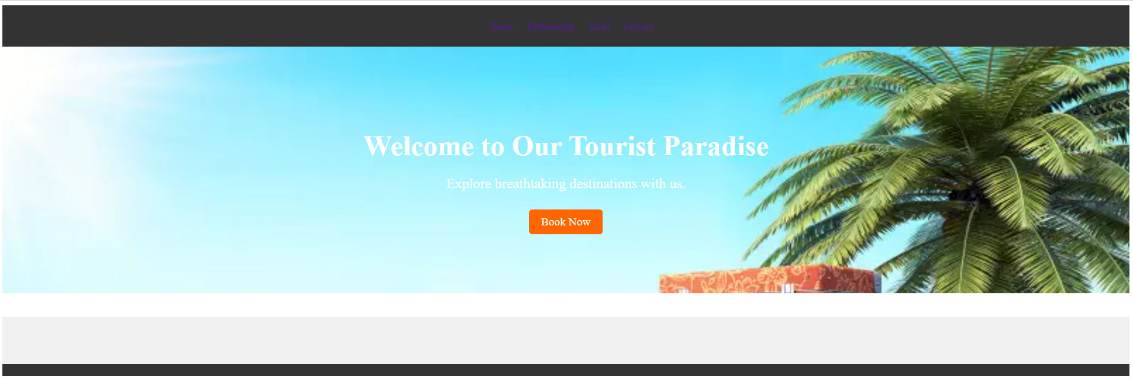

**Conclusion:-**